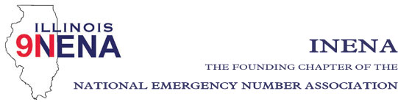

General Membership Meeting
Shelley Dallas
President
(815) 288-5911
sdallas@countyoflee.org

Diana Stiles
Vice President
(815) 879-3803
the.director@buecomm.com

Amber Adams
Secretary
(217) 568-8010
aadams@cirdc.org

John Ferraro
Treasurer
(847) 590-3407
jferraro@nwcds.org

REGION DIRECTORS:
Region 1
Alicia Atkinson
(847) 897-7878
aatkinson@redcenter.org

Region 2
Theresa Carlson
(815) 337-7911
tkcarlso@mchenrycountyil.gov

Region 3
Jeanine Kaplan
(815) 218-5467
KaplanJ@WCSO-IL.us

Region 4
Amanda Jennings
(309) 345-3729
amanda@ci.galesburg.il.us

Region 5
Phil McCarty
(217) 479-4616
pmccarty@jacksonvilleil.gov

Region 6
Allan Davis
(618) 664-1911
bond911@sbcglobal.net

Region 7
Cindy Wagner
(618) 826-6411
randolph911@yahoo.com

Region 8
Marty Doyle
(312) 743-1322
martin.doyle@cityofchicago.org

Immediate Past President
Vicki DeFord
(217) 452-7187
casscoe911@casscomm.com

Date: October 24, 2021
Time: 4:30 pm
Location: IPSTA Conference
Crowne Plaza, Springfield, IL
www.911conference.org

- Call to Order Shelley Dallas

- Approval of Prior Minutes – September 2, 2021 Shelley Dallas

- Officer Reports
- Opening Comments Shelley Dallas
-Treasurer Report John Ferraro
Action items: Approval of Treasurer’s Report

- Regional Director Reports (Region 3)
- National Officers Report
- Committee Reports
a. Education/Training – John Ferraro
b. Website – Amber Adams
c. IL TERT – LaToya Marz
d. Election results/Swearing in – Past President David Tuttle

- Statewide 911 Administrator Report - Cindy Barbera-Brelle
- Old Business
- New Business
- Next INENA Meeting
- In conjunction with IL MABAS Conference: February 24, 2022 at 11 am at Bloomington/Normal

- Adjournment

